Sensor Project

# Weekly Report 1

# Chen Siwei

## **Current Topic**

Indoor position/movement tracking with IMU.

## **Project Information:**

Controller: Seeduino Main board v1.1

Sensor: Xadow 9150 IMU

IMU is an inertial measurement unit. Basically, Xadow 9150 IMU is a 9 degrees of freedom (9dof) IMU. It provides 3 rates of angle change from Gyroscope, 3 accelerations from accelerometer and 3 values from magnetometer. By using those values we may be able to find the world linear acceleration and hence find the world linear position.

## **What have been done within the week?**

1. Set up developer environment and this includes:
   1. Arduino installation
   2. Seeduino installation (Win 8 driver issue is not easy to solve).
   3. Installed processing environment. This is used to demo the 3d rotation.

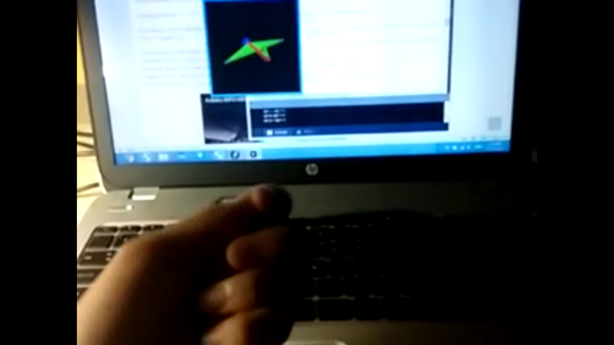

* 1. Mat Lab Installation. Mat Lab is extremely useful in the data analyzing project.

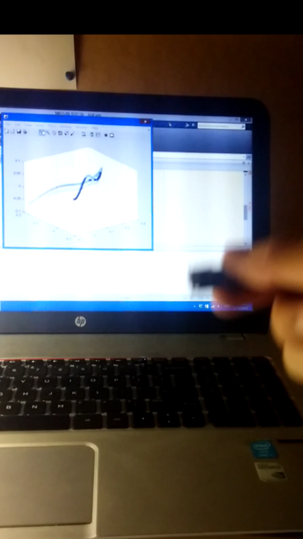

1. Found the most feasible algorithm so far.

Getting the values from the sensor is just the starting of this project and the main issue is how to process those data and output the real position data. In order to achieve this target, it is needed to integrate the rate of angle change from gyroscope and use the calculated angle to get the linear acceleration in real world. After that, integrate twice with high pass filter applied to each linear velocity and linear position.

* 1. Integrate to get angles from gyroscope

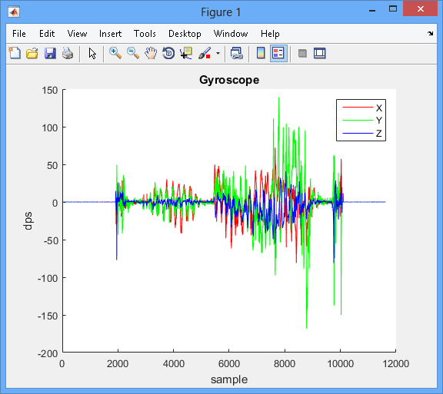

Gyroscope raw data

* 1. Acceleration Data

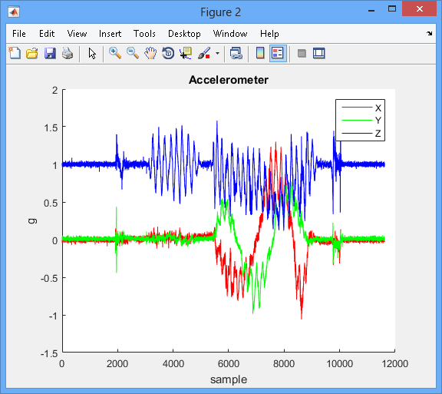

* 1. Calculate orientation via AHRS algorithm and applied on acceleration

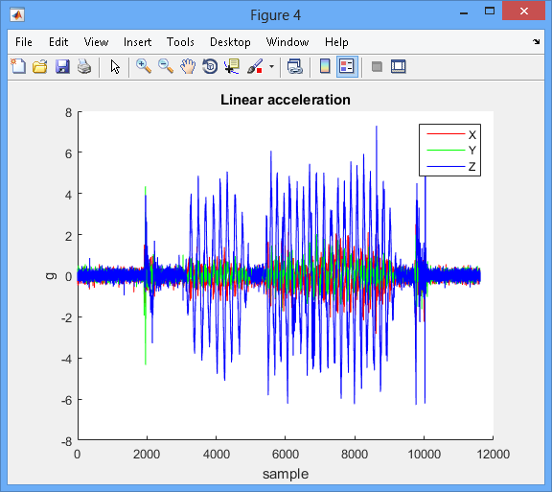

* 1. Integrate to get linear velocity

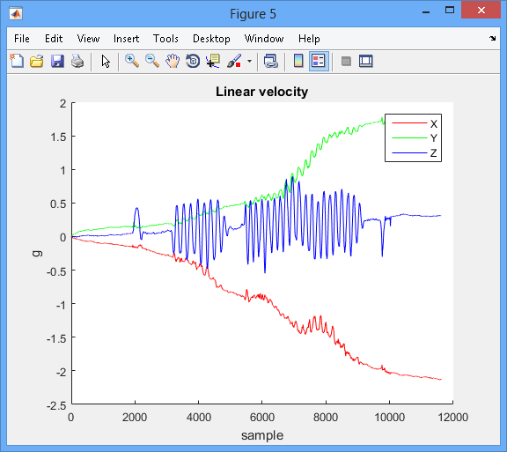

* 1. Use High Pass Filter to remove serious drift

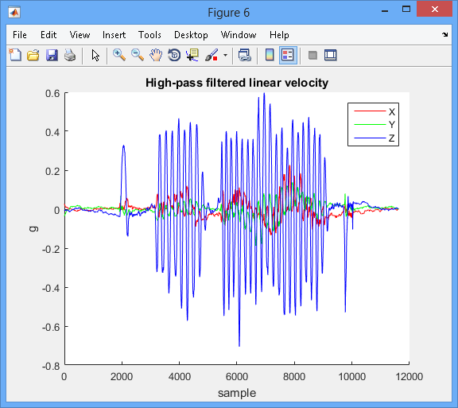

* 1. Integrate to get linear position

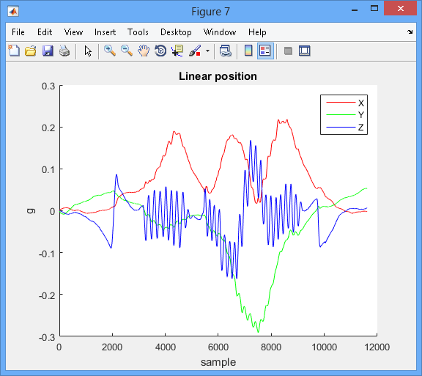

* 1. Apply high pass filter to remove serious drift

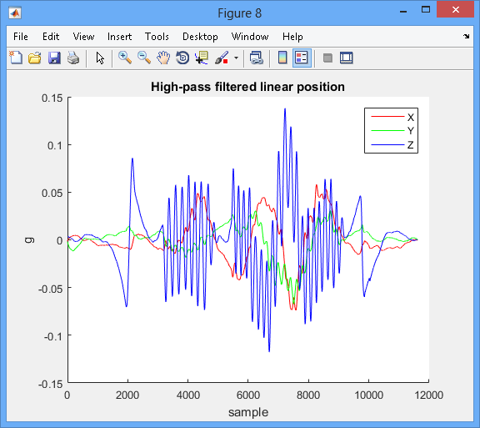

1. Problems
   1. As two high pass filters are used in the algorithm, it does remove drifts and make the outcome much more reliable. However, the graph and 3d tracking video shows that when object is at stationary, this object will be pulled slowly towards the original point. So far haven’t figured out the reason yet.
   2. The critical process of filtering needs many sets of data to make sure the outcome is more reliable. Therefore, cannot to display and the tracking and at exactly same time but it should be feasible to get the position outcome in few seconds delay.
   3. The starting and ending data may not be very valid as lack of data beyond the range.
2. Plan for next Week
   1. I think I will keep working on problem a) to resolve the issue that objects will be pulled back when it is in rest. Maybe reset its velocity when acceleration stays at 0 is a good idea. (But it may cause drifts?) Or analyze its spectrum to come out with one more filter to get rid of bad drifts and keep the real movement.
   2. Working on problem b to create an algorithm to display the tracking simultaneously but in few seconds delay.
   3. Try to make use of the data from magnetometer to get a more reliable angle, as so far the current algorithm only uses 6 degrees data.